**Searching for Painless Root Canal Clinic in Pune**

[Vanilla Smiles Clinic](https://www.vanillasmiles.dental/) in [Pune Shivajinagar](https://www.vanillasmiles.dental/contact-us/) stands out as a shining example of excellence in dentistry. Under the visionary leadership of [Dr. Abhishek Soni](https://www.vanillasmiles.dental/dr-abhishek-soni/) and [Dr. Namrata A. Soni](https://www.vanillasmiles.dental/dr-namrata-soni/), the clinic has not only transformed the Root Canal Treatment experience but also become a trusted name for a wide range of dental treatments. Whether it's a child's first dental visit or a complex cosmetic procedure, Vanilla Smiles Dental Clinic continues to redefine dental care standards, one smile at a time.

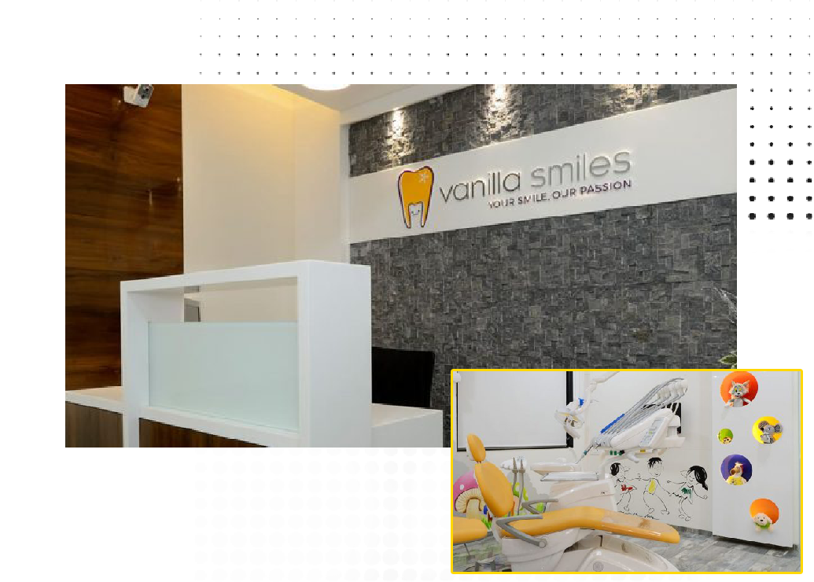

**Meet the Master Behind the Pain-Free Root Canal Approach**

***Dr. Abhishek Soni’s*** journey to becoming a pioneer in painless [Root Canal Clinic in Pune Shivajinagar](https://www.vanillasmiles.dental/root-canal-treatment-in-pune/) is marked by dedication and continuous learning. With a Bachelor's in Dental Surgery (BDS) and a Master's in Dental Surgery (MDS) with a specialization in Pediatric and Preventive Dentistry, Dr. Abhishek Soni's qualifications speak volumes about his commitment to the field. His extensive training and experience have equipped him with the skills to address even the most complex dental issues with precision and care.

In 2016, the clinic was honoured with the prestigious "Best Dental Clinic in Western India" award by Famdent, a testimony to their exceptional services and patient-centric approach.

Dr. Abhishek Soni Founder and Chief Pediatric Dentist of Vanilla Smiles Dental Clinic, and his vision of providing exceptional dental care in a warm and welcoming environment has been realized. His holistic approach to dental treatments, combined with his friendly demeanour, has earned him the trust and gratitude of countless patients.

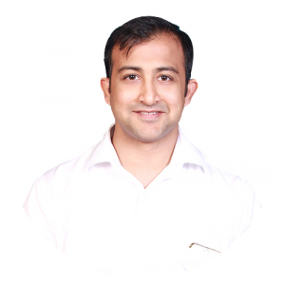 

**Dr. Abhishekh Soni Dr. Namrata Soni**

**Painless Root Canal Treatment: A Journey to Dental Health with Dr. Abhishek Soni**

Dental health is an integral part of our overall well-being, and one of the most common procedures to salvage a tooth's health is the [**Root Canal Treatment**](https://www.vanillasmiles.dental/root-canal-treatment-in-pune/). While the words "Root Canal" might evoke apprehension in many, advancements in dentistry, particularly in pain management, have transformed this once-dreaded procedure into a relatively painless experience. Leading the charge in pioneering painless Root Canal Treatments is the accomplished dentist, **Dr. Abhishek Soni.**

**The process typically involves the following steps:**

* **Diagnosis:** Through careful examination and often X-rays, the dentist determines the extent of damage and the need for a root canal.
* **Anesthesia:** Local anesthesia is administered to numb the area, ensuring a pain-free experience during the procedure.
* **Access Opening:** A small opening is made in the tooth's crown to access the pulp chamber.
* **Cleaning and Shaping:** The infected or inflamed pulp is carefully removed, and the inner chamber of the tooth is cleaned, disinfected, and shaped to accommodate the filling material.
* **Filling:** The cleaned chamber is then filled with a biocompatible material to seal the space and prevent recontamination.
* **Sealing:** A temporary or permanent filling is placed to seal the access opening.
* **Restoration:** In some cases, a tooth that has undergone a root canal may need a crown or other restoration to protect and strengthen it.

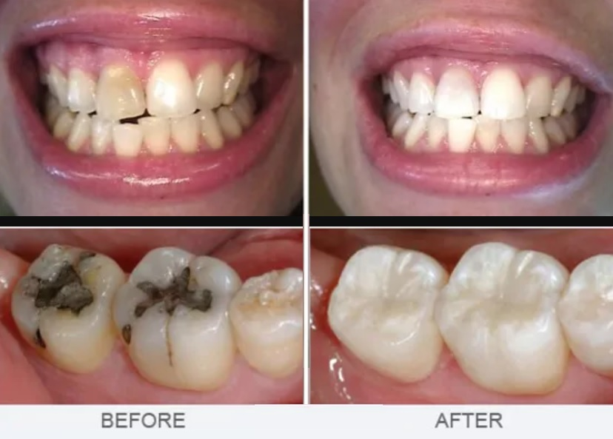

**Root Canal Treatment**

**Some Blogs of Root Canal Treatment:-**

##### **[Maintaining Oral Health After a Root Canal: Tips and Advice from Pune’s Experts](https://www.vanillasmiles.dental/blog/maintaining-oral-health-after-a-root-canal-tips-and-advice/)**

##### **[Aftercare Matters: Tips for a Smooth Recovery from Root Canal Treatment in Pune](https://www.vanillasmiles.dental/blog/tips-for-a-smooth-recovery-from-root-canal-treatment-in-pune/)**

**Some Video of Root Canal Treatment:-**

[**https://www.youtube.com/watch?v=9zLPDh_Z0zo**](https://www.youtube.com/watch?v=9zLPDh_Z0zo)

[**Contact to Our Vanilla Smile Clinic**](https://www.vanillasmiles.dental/contact-us/)**:-**

Phone No.:- 7028029383

Tel No.:- 020 2553 9383

[**Address**](https://www.vanillasmiles.dental/contact-us/)**:-**

Soni Capital, 2nd Floor, Near Shreyas Hotel,

1237, Apte Road, Shivaji Nagar, Pune, Maharashtra 411004 India

[**Get Direction**](https://goo.gl/maps/87AJ92zrmCxqBpXv8)**:-**

[**Appointment Time:-**](https://www.vanillasmiles.dental/contact-us/)

Tuesday to Saturday: 10 am–7 pm

Sunday: 9 am–7 pm

Monday: Closed

**Website:-** [www.vanillasmiles.dental](http://www.vanillasmiles.dental)